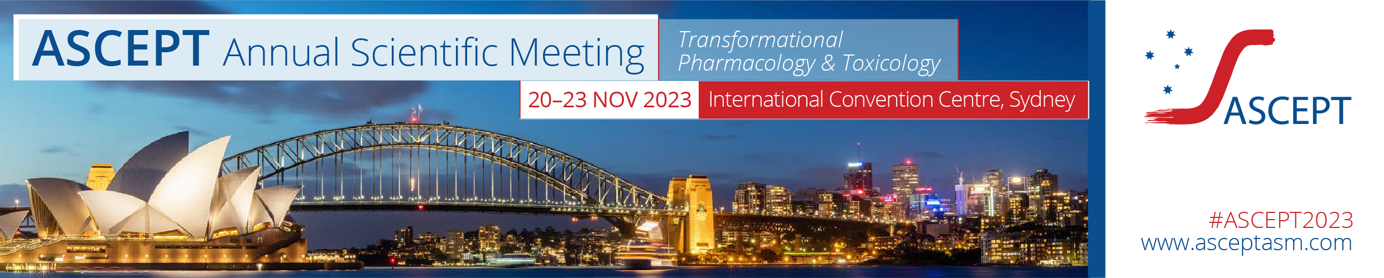

Call for WORKSHOP PROPOSALS

Submission is now open for proposals for workshops to be run at the ASCEPT 2023 Annual Scientific Meeting from 20 – 23 November 2023. The theme of the meeting is Transformational Pharmacology & Toxicology.

ASCEPT recognises the diversity of their membership and is committed to the values, attitudes and conduct of equity, diversity and inclusion to create a collegial, collaborative and successful professional community. ASCEPT is committed to achieving equity and inclusion through balancing representation across its program in alignment with the diverse composition of their membership. Your application should describe aspects of equity, diversity and inclusivity with the selection of participants, including the proportion of male and female contributors, the career level (early, mid, senior), diversity of geographical locations, minority group representation etc. Download the ASCEPT policy here.

The deadline for submitting workshop proposals is Monday 10 July 2023.

Workshop format
The ASCEPT 2023 ASM Organising Committee encourages the submission of innovative and interactive workshop proposals that take advantage of the less formal format.

Workshops will be restricted to a fixed length of two hours and are scheduled to run on Monday 20 November 2023. The number of available slots is limited and the final composition will be decided by the ASCEPT ASM 2023 Organising Committee. Please note that ASCEPT will only provide venue and required audio visual equipment. No catering will be supplied, unless organise and paid for by the workshop organiser.

Meeting registration and travel expenses
If your proposal is successful the workshop applicant, chairperson and speakers will be requested to register for the meeting. Workshop attendance will only be offered to those who have registered for the full meeting.

ASCEPT members, including the workshop applicant, chairperson/facilitator and any speakers, are required to fund their own registration and travel expenses. Non-member speakers may be offered a single day complimentary registration at the discretion of the Organising Committee.

Instructions for the preparation of your workshop proposal
Proposals must include sufficient supporting material to permit the Organising Committee to evaluate the quality of and potential interest in the workshop. We particularly encourage submissions that align with the meeting theme.

Workshop proposals are to be submitted on the application form by Monday 10 July 2023. Please upload your application via https://expertevents.eventsair.com/ascept-2023/workshop-submission

After the submission
The ASCEPT ASM 2023 Organising Committee will rank all submitted proposals according to quality, breadth of interest, interactive format and adherence to EDI principles. Submissions that follow a workshop format are encouraged. Applicants will be advised via email whether or not their workshop proposal has been accepted by Monday 24 July 2023.

Confirmation of workshop program and key participants

Successful applicants will be required to submit their final program, including any speaker and chairperson/facilitator names, to the meeting secretariat via email to asceptasm@expertevents.com.au by Friday 4 August 2023.

Proposal for workshop

Please complete all details below and submit your application by Monday 10 July.
Please upload your application via
https://expertevents.eventsair.com/ascept-2023/workshop-submission

Applicant details:
Name:
Affiliation:
Address:
Phone: |  | Email:

Workshop details:
Workshop title:
Outline the purpose/aims of the workshop – this will be used as the abstract used in the program (100-200 words). Include a description of the anticipated audience.
Does the workshop align with the meeting theme, Transformational Pharmacology and Toxicology? Briefly indicate how so. Note that alignment isn’t necessary for acceptance in the ASM.
Provide a draft timetable of the format of the workshop, noting that each workshop is capped at 2 hours.
Brief statement about how your proposed workshop addresses the goals of equity, diversity and inclusion to meet ASCEPT’s commitment to balancing representation across their activities in alignment with the diverse composition of their membership.
(e.g. through the consideration of workshop speakers, chairs etc.)
Potential sources of sponsorship (list organisation name and contact details and advise who will contact them). It is expected that workshop organisers will seek support for invited speakers.
Are there any special requirements you would like to discuss with the conference organisers Expert Events? e.g. round table format vs symposia seating. Note that additional charges may apply for room set-up.

Proposed Chairperson(s)/Workshop Facilitators:
Name (including academic title):
Position title:
Affiliation:
Country:
Email:
Society member? | ASCEPT NON-MEMBER

*If your workshop will include specific participants in panel discussions or short talks, please list them below*

Proposed Participant 1:
Name (including academic title):
Position title:
Affiliation:
Country:
Email:
Draft presentation title, if applicable:
Society member? | ASCEPT NON-MEMBER
Agreement: | The speaker has agreed to participate in the workshop if accepted for the program

Proposed Participant 2:
Name (including academic title):
Position title:
Affiliation:
Country:
Email:
Draft presentation title, if applicable:
Society member? | ASCEPT NON-MEMBER
Agreement: | The speaker has agreed to participate in the workshop if accepted for the program

Proposed Participant 3:
Name (including academic title):
Position title:
Affiliation:
Country:
Email:
Draft presentation title, if applicable:
Society member? | ASCEPT NON-MEMBER
Agreement: | The speaker has agreed to participate in the workshop if accepted for the program

Include additional boxes as required.

