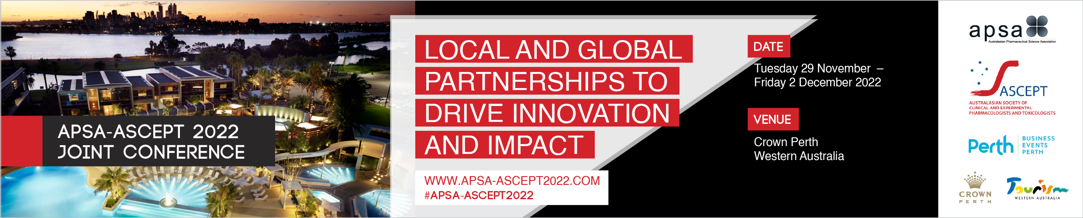

Call for symposia proposals

Submission is now open for symposia proposals to be presented at the APSA-ASCEPT 2022 Joint Conference to be held from Tuesday 29 November — Friday 2 December 2022 in Perth. The theme of the conference is Local and global partnerships to drive innovation and impact.

APSA and ASCEPT recognise the diversity of their membership and are committed to the values, attitudes and conduct of equity, diversity and inclusion to create a collegial, collaborative and successful professional community. Both APSA and ASCEPT are committed to achieving equity and inclusion through balancing representation across symposia proposals in alignment with the diverse composition of their membership. Your application should describe aspects of equity, diversity and inclusivity with the selection of chairs and speakers, including the proportion of male and female contributors, the career level (early, mid, senior), diversity of geographical locations, minority group representation etc. Download the ASCEPT policy here.

Proposals that incorporate topics aligned with the interests of both APSA and ASCEPT would be preferred.

The deadline for submitting symposia proposals is Monday 30 May 2022.

Symposium format
Each symposium will run for two hours and is to incorporate four speakers, each with an allotted presentation time of 20 minutes plus 5-10 minutes to allow audience members to ask questions of presenters and for an exchange of views.

Please ensure that you have sought agreement from speakers to participate in your symposium before including them in the application.

Conference registration and travel expenses
If your proposal is successful, the symposium applicant, chairperson and speakers will be requested to register for the conference.

APSA and ASCEPT members, including the symposium applicant, chairperson and speakers, are required to fund their own registration and travel expenses.

Non-member speakers may be offered either a single day or full complimentary registration.

For each symposium, applications for a budget of up to AUD1,000 to assist with the travel expenses of non-member speakers will be considered if a compelling case is made. In addition, symposium applicants should seek sponsorship to assist with additional speaker costs.

Instructions for the preparation of your symposium proposal
Proposals must include sufficient supporting material to permit the Program Committee to evaluate the quality of, and potential interest in, the symposium.

Symposium proposals are to be submitted on the application form by Monday 30 May 2022. Please upload your application via https://expertevents.eventsair.com/aspa-ascept-2022/symposiumsubmission

After the submission
Applicants will be advised whether or not their symposium proposal has been accepted by Monday 20 June.

Confirmation of symposium speaker names, presentation titles and abstracts
Successful applicants will be required to accept or decline the offer to organise a symposium via email to
apsa-ascept@expertevents.com.au by Friday 1 July.

Individual symposium presenters will be required to submit their abstract via an on-line portal from Monday 4 July. The deadline for abstract submission is Friday 30 September.

Proposal for symposium

Please complete all details below and submit your application by Monday 30 May 2022.
Please upload your application via https://expertevents.eventsair.com/aspa-ascept-2022/symposiumsubmission

Applicant details:
Name:
Affiliation:
Address:
Phone: |  | Email:

Symposium details:
Symposium title:
Special Interest Groups and/or streams involved in the symposium:
Audience profile:
Descriptive summary of the symposium (abstract)
(100–200 words):
Brief statement about how your proposed symposium addresses the goals of equity, diversity and inclusion to meet APSA and ASCEPT’s commitment to balancing representation across their activities in alignment with the diverse composition of their membership.
(e.g. through the consideration of symposium speakers, chairs etc.)
Potential sources of sponsorship (list organisation name and contact details and advise who will contact them):

Proposed Chairperson(s):
Name (including academic title):
Position title:
Affiliation:
Country:
Email:
Society member? | APSA ASCEPT NON-MEMBER

Proposed Speaker 1:
Name (including academic title):
Position title:
Affiliation:
Country:
Email:
Draft presentation title:
Society member? | APSA ASCEPT NON-MEMBER
Agreement: | The speaker has agreed to participate in the symposium if accepted for the program

Proposed Speaker 2:
Name (including academic title):
Position title:
Affiliation:
Country:
Email:
Draft presentation title:
Society member? | APSA ASCEPT NON-MEMBER
Agreement: | The speaker has agreed to participate in the symposium if accepted for the program

Proposed Speaker 3:
Name (including academic title):
Position title:
Affiliation:
Country:
Email:
Draft presentation title:
Society member? | APSA ASCEPT NON-MEMBER
Agreement: | The speaker has agreed to participate in the symposium if accepted for the program

Proposed Speaker 4:
Name (including academic title):
Position title:
Affiliation:
Country:
Email:
Draft presentation title:
Society member? | APSA ASCEPT NON-MEMBER
Agreement: | The speaker has agreed to participate in the symposium if accepted for the program
Appearance: | This speaker from outside Australasia is only available to be a remote speaker

