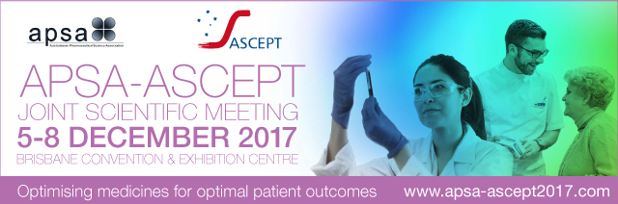
APSA STUDENT TRAVEL REIMBURSEMENT FORM
This form is to be filled out by APSA student members and submitted to APSA (details below) by
Friday, 27 October 2017 in order to receive a partial travel reimbursement for attendance at the 2017 APSA-ASCEPT Joint Scientific Meeting. Please note, only APSA student members who are travelling from interstate/NZ and are the presenting author of an oral or poster presentation at APSA-ASCEPT 2017 will be eligible for a partial travel reimbursement. Students must be financial members of APSA prior to the abstract submission deadline (Monday, 18 September 2017).
If eligible, students will receive a cheque available for collection from the registration desk during the conference.
Regardless of whether the cheque is to be made out to the student, supervisor or institution, this form must be signed by your supervisor/Head of Department/Head of School or equivalent.
Student Name:
Institution:
Abstract ID:
Presentation Type:
Presentation Title:

Name to whom cheque should be made out:
Please note: if the cheque is to be made out to you personally or to your supervisor, please provide the name as it appears on your/their bank account. If the cheque is to be made out to your school, please ensure you have the correct name of the school/department/institution – it would be best to check this naming with your finance administration team.
Signature of Student:
Name of Supervisor/Head of Department/Head of School:
Signature of Supervisor/Head of Department/Head of School:
Please obtain the relevant signatures, scan and email to info@apsa-online.org by Friday, 27 October 2017 to be eligible for a partial travel reimbursement. Applications received after this date will not be considered.

