Presentation title in sentence case (bold)
John A Smith¹, Jack N Smith^{1,2}. Dept Name, Organisation¹, City, STATE; Dept Name, Organisation², City, STATE. (please abbreviate state)

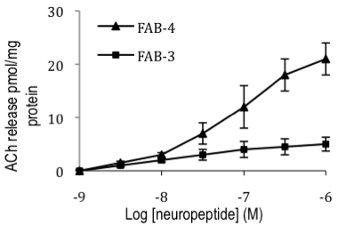
Introduction. Text to begin immediately following the heading and without additional line spacing.
Aims. Text to begin immediately following the heading and without additional line spacing.
Methods. Text to begin immediately following the heading and without additional line spacing.
Results. Text to begin immediately following the heading and without additional line spacing.
Discussion. Text to begin immediately following the heading and without additional line spacing. Do not change the margins, the font, size or any other setup on this template. The abstract should be left-and right-justified. Line spacing must be single. The abstract must be one page only. The abstract must be typed in Times New Roman 10 point. Do not use bold in the abstract text, only the title should be in bold. Abstract pages will be printed in black and white only, therefore it is preferred that all tables and images are greyscale. Please pay particular attention to these instructions as abstracts that do not conform will not be accepted by the editors. If you have any problems please call Leanne at Expert Events on 07 3848 2100.

The text should be as informative as possible.

McCartney P (2001) J J 56:23-33
Starr R et al (2005) Pharmacology of FAB-4, ed Ono Y. pp 12-23, Tokyo, Abbey Road Press

